DS ASSIGNMENT -2
Aim: The growth of supermarkets in the most populated cities is increasing and market competitions are also high. The dataset is one of the historical sales of a supermarket company which has been recorded in 3 different branches for 3 months data.
Donut chart
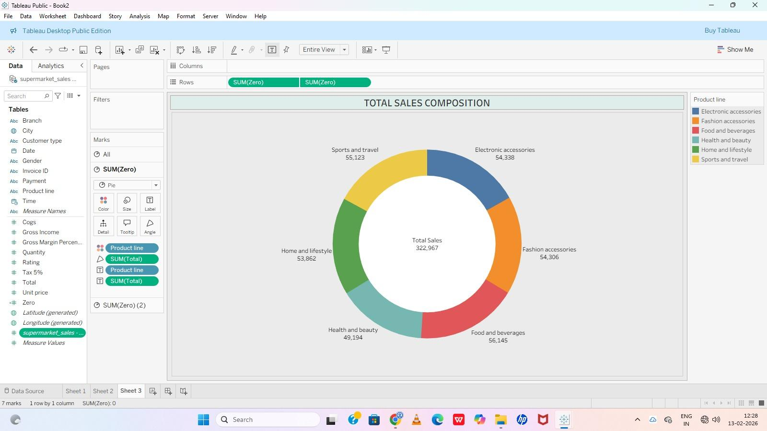
- Area chart
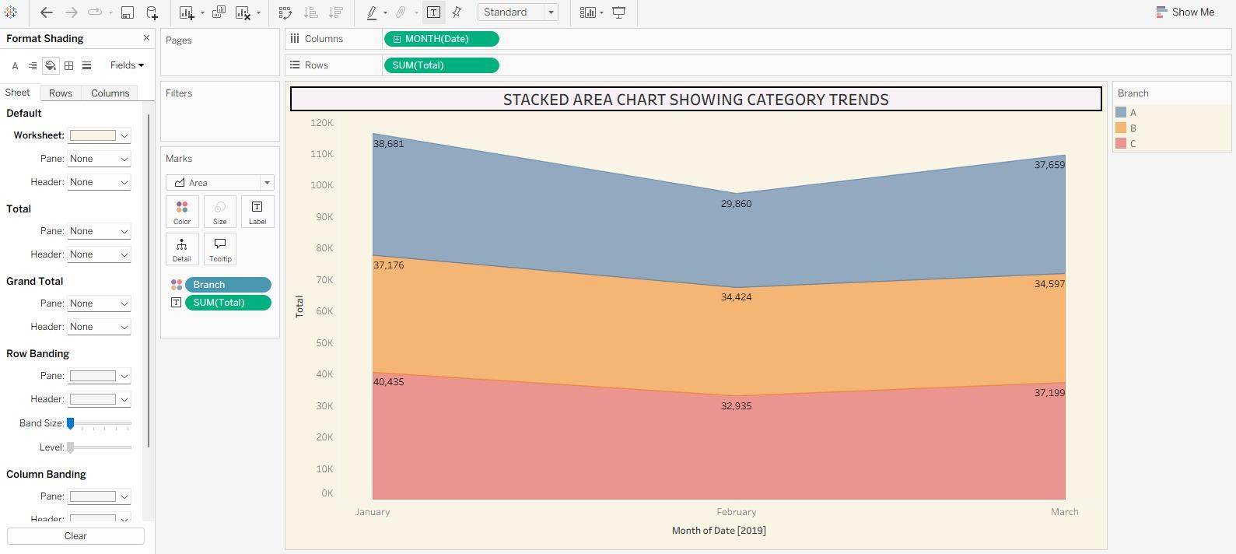

- Text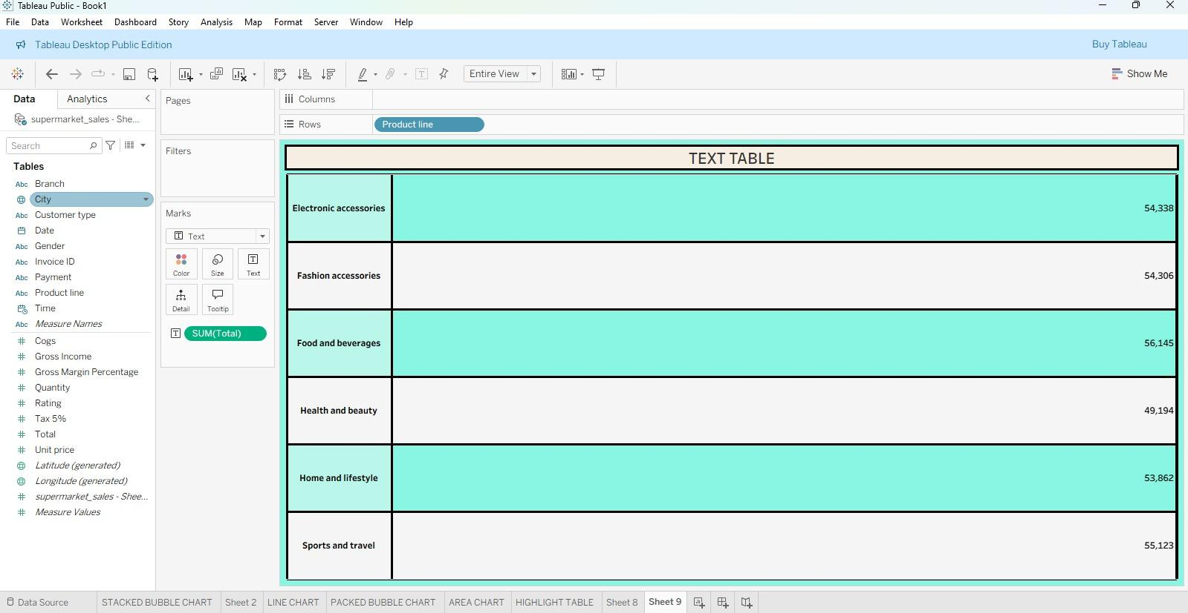

- Highlighted table
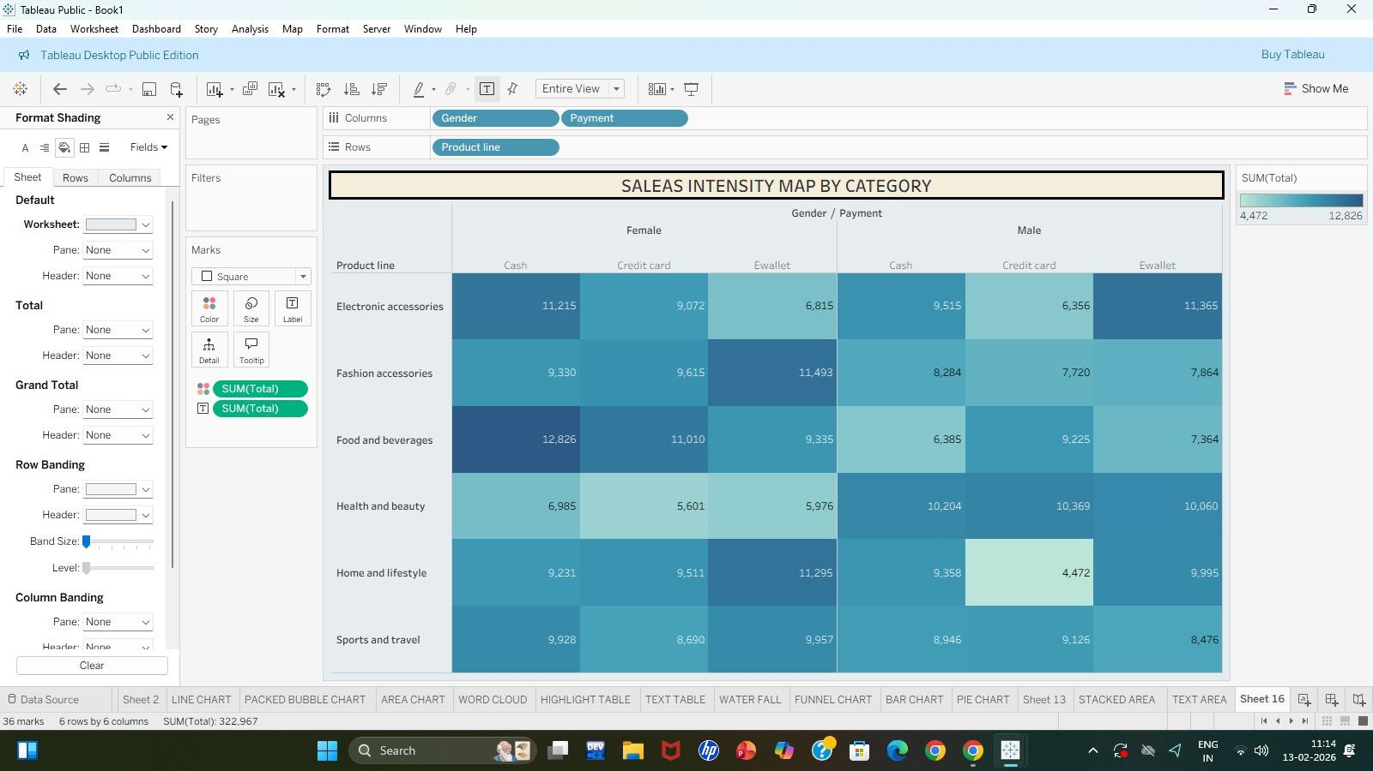
- WordCloud
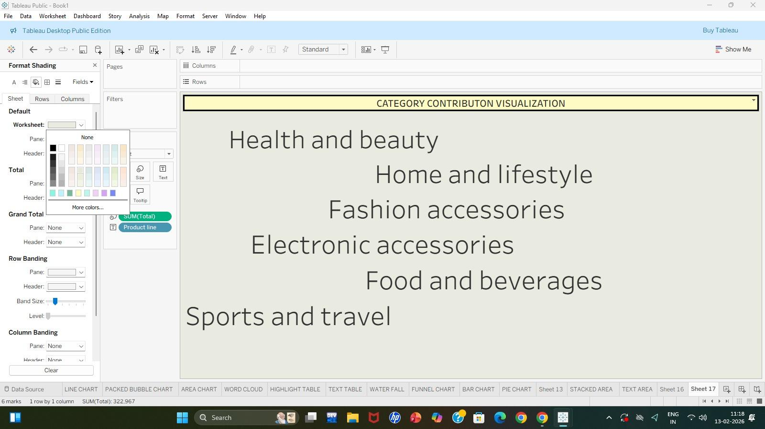
- Funnel chart
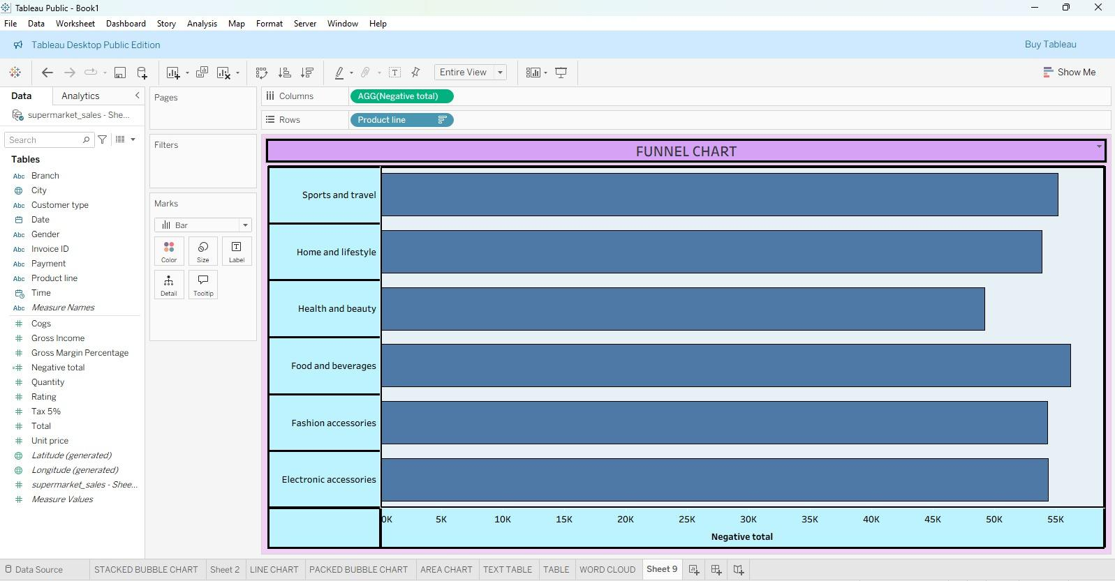

- Waterfall
